**LAB-DAY-1**

**NAME**:Mary Sushmija.X M

**REGNO**:192124100

**Date**:16-08-2023

**1.Addition:**

Input:

num1=as.integer(readline(prompt="enter the num1:"))

num2=as.integer(readline(prompt="enter the num2:"))

sum=num1+num2

print(sum)

Output:

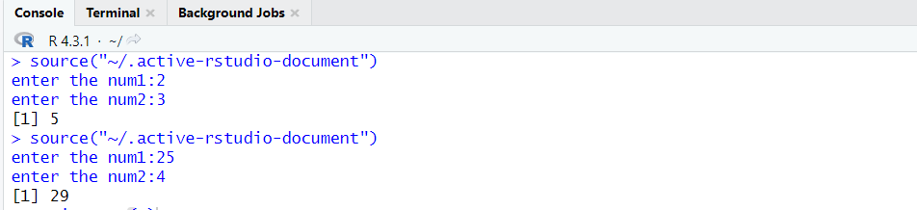

**2.Mean**

Values: (12,7,3,4.2,18,2,54,-21,8,-5)

Input:

# Create a vector.

x <- c(12,7,3,4.2,18,2,54,-21,8,-5)

# Find Mean.

result.mean <- mean(x,trim = 0.3)

print(result.mean)

Output:

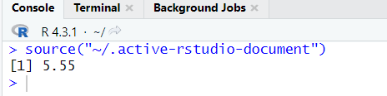

**3.Bar plot**

Input:

H<- c(12,35,54,3,41)

barplot(H)

Output:

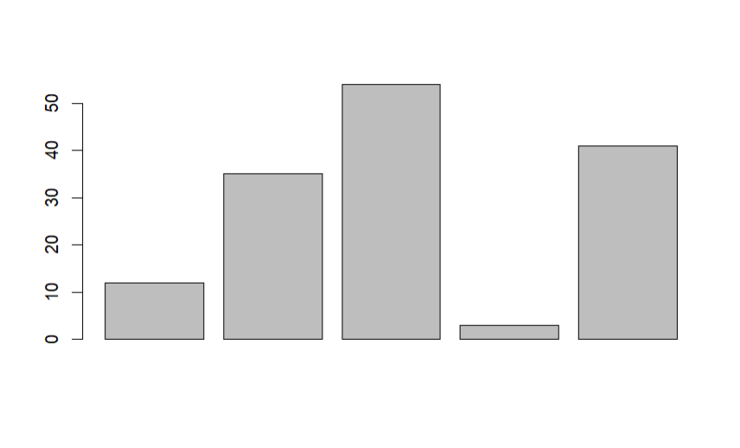

**4.Box plot:**

Input:

b <- c(10,12,13,14,17,19,20,30,50,70,90,100)

print(boxplot(b,col="green"))

Output:

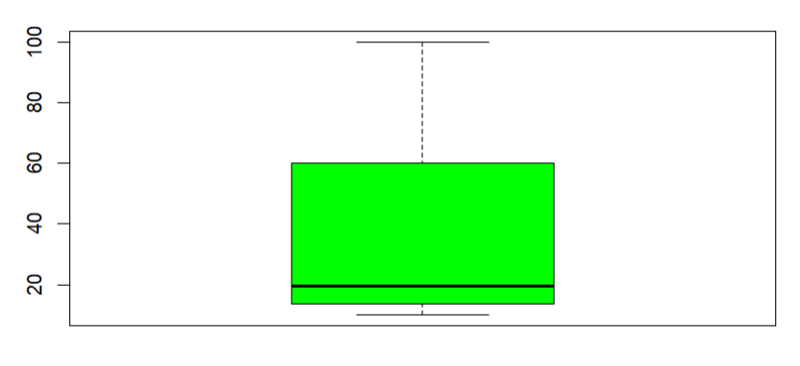

**5.Decision Tree:**

Input:

# Load the party package. It will automatically load other

# dependent packages.

library(party)

# Create the input data frame.

input.dat <- readingSkills[c(1:105),]

# Give the chart file a name.

png(file = "decision_tree.png")

# Create the tree.

output.tree <- ctree(

nativeSpeaker ~ age + shoeSize + score,

data = input.dat)

# Plot the tree.

plot(output.tree)

# Save the file.

dev.off()

